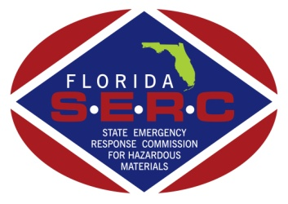

**State Emergency Response Commission**

**Training Task Force (TTF)**

**Conference Call Agenda**

**June 1, 2023 – 1:30 PM - 2:30 PM**

1. **Current Business**
2. **Electric Vehicle Lithium-Ion Battery Working Group**

* Florida Division of State Fire Marshal Director JoAnne Rice bought forth information for the upcoming Lithium-Ion Symposium being held September 7-8, 2023. The SERC and Fire Mashal’s Office are collaborating on this issue. Director Rice suggested that this group provide subject matter experts to talk at this event on Florida EV Response Best practices that can be shared with everyone.
* Chief Lamm spoke to the different documents sent to the group and that siting the Best Practices be used and that a living document would be a good option as information and procedures change so quickly.
* Chief Lamm also discussed the possibly of adding an EV training component to the hazmat symposium in the future, will verify and provide future updates.
* Mr. Dietrich introduced FDEP Jeff Gregg Manager for the Hazardous and Solid Waste Compliance Assistance Program. Mr. Gregg discussed the Federal EPA and State regulations on EV disposal, the struggle post Hurricane Ian and the hazards involved with the transportation/recycling/disposal of damaged lithium-ion batteries.
* Capt. Bloski commented that the SERC best practices would need to be compatible throughout all FL counties and that it would be a good idea for our team to reach out to towing and recovery companies to ensure everyone has the same with information when transporting EV’s.
* Mr. Burt McKee discussed the program we are creating might be modeled on a previous SERC initiative that had fantastic success the Pesticide collection program “Cleansweep”. Mr. McKee suggested that we build upon that program and have amnesty days with the possibility of securing a federal funding source.

1. **To Do’s**

* Obtain best practice information from Florida Subject Matter Experts and compile Information to be shared with the group.
* Present information at July SERC in St. Augustine.
* If approved send a few representatives (possibly from Hollywood, FL) to the September Lithium-Ion Symposium to present best practices documentation.
* Coordinate with towing industry on hazards of towing EV’s after accidents/water instruction and 1st Responder mitigation.
* Continue to coordinate with the Florida Division of State Fire Marshal
* Work with FDEP on EV disposal and a potential lithium-ion disposal or recycling initiative.

1. **Upcoming Events**
   1. Schedule Next Conference Call TBD
2. **Adjournment**